Containerize 3-tier PHP TODO application with Docker

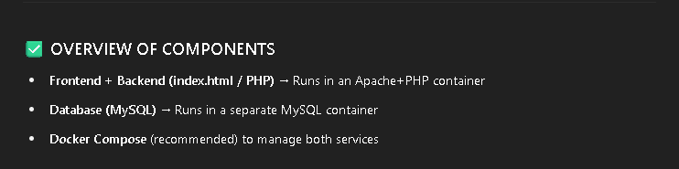

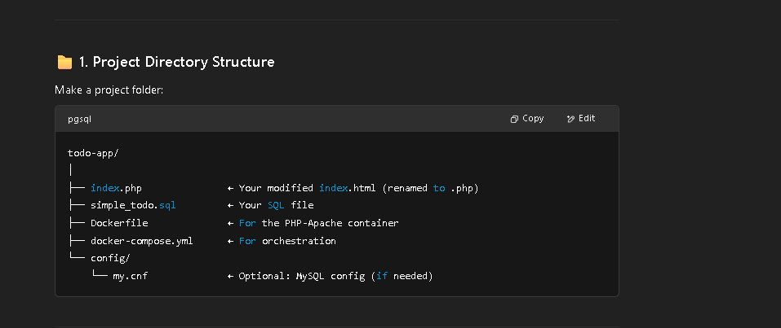

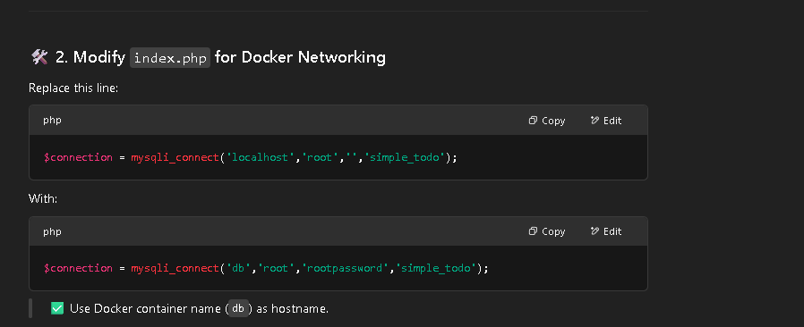

$connection = mysqli_connect('db','root','rootpassword','simple_todo');

🐳 3. Dockerfile for PHP-Apache
Docker file
FROM php:7.4-apache

# Install mysqli
RUN docker-php-ext-install mysqli

# Copy app code to container
COPY index.php /var/www/html/

# Set correct permissions
RUN chown -R www-data:www-data /var/www/html

🐳 4. docker-compose.yml

version: '3.8'

services:
web:
build: .
container_name: php_web
ports:
- "80:80"
depends_on:
- db

db:
image: mysql:5.7
container_name: mysql_db
restart: always
environment:
MYSQL_ROOT_PASSWORD: rootpassword
MYSQL_DATABASE: simple_todo
ports:
- "3306:3306"
volumes:
- db_data:/var/lib/mysql
- ./simple_todo.sql:/docker-entrypoint-initdb.d/simple_todo.sql

volumes:
db_data:

🚀 5. Build and Run
Run these from the todo-app/ folder:
docker-compose build
docker-compose up -d

6. Test the App
Visit your EC2 public IP:
http://<EC2_PUBLIC_IP>

